23 February 2021

Dear Parents and Carers

Information and Consent form for asymptomatic COVID-19 testing in Sir Graham Balfour School

I shall be writing to you shortly with details of our staggered return to school from the 8th March. This letter has the sole intention of seeking your consent for your child to be tested for Covid-19 on their return.

As you may have heard last night, there is a requirement on schools to offer asymptomatic Covid testing to students as part of the Government’s strategy to fully re-open schools from the 8th March. We will need to carry out 3 tests in school with students in school, in order to give assurance that, at that moment in time, students are Covid-free; in addition, this is intended to show them how to carry out these tests themselves. The Government has stated that, after these three school-based tests, students will be required to carry out testing at home, with kits that will be distributed to them.

The tests we will be carrying out are called Lateral Flow Tests, which return a result within 30 minutes of testing. They involve nasal only swabbing. The test is very brief, may be a little uncomfortable, but is not in any way painful or harmful.

Since Christmas, we have assembled a core group of school staff who have been carrying out testing with school staff and the children of key workers who have been with us throughout lockdown. Our testing process is safe and secure and monitored at all times.

The purpose of this letter is to seek your consent for your child to be tested on their return to school. Please be assured that no-one will be tested without written consent. If we do not receive the enclosed completed consent form back, we will not be able to test your child for asymptomatic Covid-19.

As headteacher of Sir Graham Balfour School, I do urge you to give your consent, in order that we all do our bit in reducing the transmission of this virus which has caused so much harm and disruption to us all.

I have enclosed for your information a two-page outline of how your child will self-administer the test. Our team will offer help and guidance in how to carry out the test properly, and as you would expect, they will be very supportive whilst doing so.

I have also enclosed a Privacy Notice and a FAQ sheet on the use of personal data in relation to these Lateral Flow Tests for your information. Please do read them carefully and be assured that we can and will only use the data collected for the specific purpose outlined in those documents.

Please read carefully the ‘Terms of Consent’ below; this is wording drawn up by the Government which outlines what you are consenting to. Please note that in most cases, you will only hear from us if your child has tested positive. Negative tests will not normally be communicated. Please also note that these tests can only be carried out on people who feel fine and healthy. If there is any hint of your child having any Covid symptoms, they must stay at home and book a test via the NHS as usual.

I hope that by consenting for your child to be tested on a regular basis, it will give you a little peace of mind in these uncertain times. If you are happy to consent, please fully complete the enclosed form and return it via your child to Reception on the day they return to school.

If you have any questions on any of the enclosed, please do not hesitate to email us at office@sirgrahambalfour.staffs.sch.uk using ‘LFD testing’ in the subject box.

Kind regards

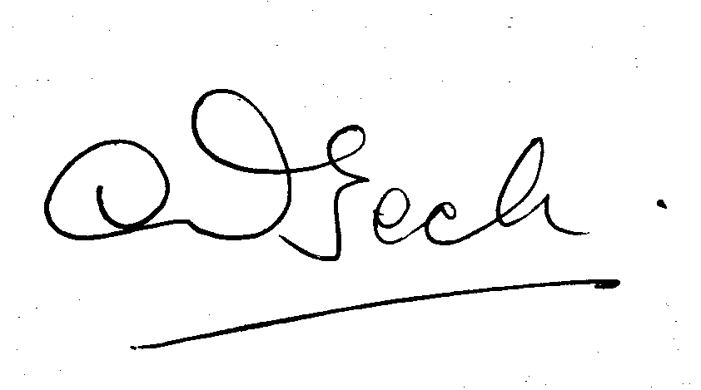

Mrs Lesley Beck
Headteacher

Introduction

This consent form is for participation in tests designed to detect asymptomatic coronavirus cases. Anyone experiencing symptoms should follow government guidelines to self-isolate, even if they have had a recent negative lateral flow test.

Consent relates to the following groups of students/pupils and staff as follows:

- For pupils and students younger than 16 years - this form must be completed by the parent or legal guardian. Please complete one consent form for each child you wish to participate in testing.
- Pupils and students over 16 who are able to provide informed consent - can complete this form themselves, having discussed participation with their parent / guardian if under 18.

- For any pupil or student who does not have the capacity to provide informed consent - this form must be completed by the parent or legal guardian. Please complete one consent form for each child you wish to participate in testing.
- Staff will complete this form themselves.
Terms of consent

- I have had the opportunity to consider the information provided by the school about the testing, ask questions and have had these answered satisfactorily, based on the information presented in the letter dated 23rd February 2021 and the attached Privacy Notice.

- In the case of under 16s, I have discussed the testing with my child and my child is happy to participate. If on the day of testing they do not wish to take part, then they will not be made to do so and consent can be withdrawn at any time ahead of the test.

- I consent to having / my child having a nose only swab for lateral flow tests. I / my child will self-swab if I / my child is able to otherwise I understand that assistance is available. In the case of under 16s or pupils who are not able to provide informed consent, I have discussed the testing with my child and they are happy to participate and self-swab (with assistance if required).

- I understand that there may be multiple tests required and this consent covers all tests for the below named person. If, on the day of testing I / they do not wish to take part, then I understand I / they will not be made to do so and that consent can be withdrawn at any time ahead of the test.

- I consent that my / my child’s sample(s) will be tested for the presence of COVID-19.

- I understand that if my /my child’s result(s) are negative on the lateral flow test I will not be contacted by the school/college except where I am / they are a close contact of a confirmed positive.

- If the lateral flow test indicates the presence of COVID-19, I consent to having / my child having a nose and throat swab for confirmatory PCR testing. I/they will follow the instructions on the PCR Kit to return the test the same day to an NHS Test & Trace laboratory.

- If the lateral flow test indicates the presence of COVID-19, I commit to ensuring that I / my child is removed from school premises as promptly as possible, bearing in mind I / they may have some anxiety following a positive test result.

- I agree that I / they will need to self-isolate following a positive lateral flow test result, until the results of the confirmatory PCR have been received.

- I agree that if my / my child’s test results are confirmed to be positive from this PCR test, I will report this to the school / college and I understand that I/ my child will be required to self-isolate following public health advice.

- I consent that if a close contact of my child tests positive I/my child will be required to self isolate for 10 days in line with Government guidelines to self-isolate.

First Name (of student or member of staff)
Last Name (of student or member of staff)
Year group (if student)
Date of Birth (of student or member of staff)
Gender (of student or member of staff) – this information is needed for Department for Health and Social Care research purposes. | Male/Female/prefer not to say
Ethnicity (of student or member of staff) - this information is needed for Department for Health and Social Care research purposes. | Asian or Asian British  Black, African, Black British or Caribbean  Mixed or multiple ethnic groups  White  Prefer not to say
Is student or member of staff currently showing any COVID-19 symptoms?
Home Postcode
Email Address – this is where positive test results will be sent

Mobile Number – this is where positive test results will be sent.
Name of parent/guardian giving consent (if child is below 16 or incapable of giving own consent):

Relationship to test subject:
Signature of parent/student if 16 or over/member of staff (typing out your name is sufficient if you are filling in this form digitally)
Date of signature:
Details of any health or accessibility issues which might affect a child’s safe participation in the testing exercise. (continue on back if necessary)
CONSENT FORM FOR LATERAL FLOW TESTS: PLEASE COMPLETE AND RETURN TO RECEPTION ASAP AND LATEST BY THE DAY YOUR CHILD RETURNS TO SCHOOL

