

Dear Parents, Carers, Students, Grandparents and all other members of our Community
Balfour
Newsletter
Christmas 2019
This term seems to have passed incredibly quickly. Our Year 7 students are (mostly) settled in and enjoying being part of the Balfour Family. Our Year 11 students have (mostly) got their heads down, preparing for their rapidly approaching GCSE exams with energy and determination. Year 10 students have (mostly) adapted very well to the rigours of GCSE study. Year 9 students are considering the next important stage of their education, where, for the first time, they have some choice over what they will be studying. We look forward to meeting with parents and carers in the New Year, when we will have our Pathways Meetings with you. Year 8 students are enjoying no longer being the youngest in school! Our Year 12 and 13 students are great role models – demonstrating their ambition for their future lives on a daily basis and showing our younger students what it means to be a Senior in Sir Graham Balfour.

School is a busy, bustling, exciting and great place to be. As ever, as we approach the end of term, there are a few things I would like to share with you:

Vision and Values of Sir Graham Balfour School
We have all been delighted with the way in which our Vision and Values have been embraced by our students and staff this year. By focusing on the positive messages held within our values, school has become an even more pleasant and effective place to be for all. Our conversations with children often centre around one of more of those values, which you will see below. Your support with explaining and discussing these values at home would be great:

- Commitment to excellence
- Responsibility for ourselves and others
- Ambition for ourselves and others
- Respect, Kindness and Compassion for ourselves and others
- Care for the local and wider Community
- Perseverance and resilience
- Pride in working hard and the success it brings
Update to Behaviour for Learning procedures
We regularly look at the ways in which we encourage and reward great behaviour and attitude to learning in our school. The tens of thousands of House Points, Praise Postcards and Headteacher’s Awards are testament to the successes achieved by the vast majority of our students. The very healthy competition which exists between the different Houses results in students actively seeking ways to boost their House Group’s House Point tally; this is wonderful to see. Perhaps inevitably in a school with nearly a thousand students, there are some students and some occasions where behaviour and attitude are not what we would wish to see. And then add to that mix the challenges of puberty and peer pressure…! Nonetheless, I do make it very clear to parents and carers and to the student body that school is a place of learning, and that we cannot allow any child’s behaviour to adversely affect the learning of others. Our teachers, House Tutors and House Heads particularly work hard to help modify children’s behaviour, but please do support us. Everyone will benefit if children see the school and home working together.

We are shortly to make a few changes to our behaviour policy. As with the reports, we will be looking to bring together Behaviour and Attitude to learning. This will see the wording changed for the different levels of BCs, which will include from now on not just unacceptable behaviour, but lateness to lessons, poor uniform, late or incomplete homework. I will send out the amended wording after Christmas, and the children will attend assemblies where the new structures will be outlined.

Please be reassured, the vast majority of students in our school have fewer than 5 BCs in their total record and similarly, have never received a detention. Our aim is to make sure that all students work to these same, high standards.

Uniform
As ever, I want to thank you for your support of our school uniform. If you need to buy additional items in the sales, please do first look at our uniform list on the school website, in order that items you buy are appropriate and fit our uniform code.

If you have any still usable items of uniform not needed by your son/daughter, we would be very grateful to receive them. Please send in clean items via Reception and we will be sure to make good use of them.

Parents Evening Booking System
We are currently trialling an online booking system which allows parents to book appointments with teachers on Parents’ Evening. This is intended to avoid the situation where students forget to make appointments, lose their appointment sheets, or deliberately try and avoid particular teachers… The trial is with Year 11 at the moment, and we will be very grateful for any feedback received.

Consultation on change to lunchtime
I will send out a letter after Christmas opening up a consultation to shorten our school day by ten minutes, by reducing the lunch break by the same amount of time. The key reason is that for a number of children, the 50 minute break is slightly too long, encouraging some, often out of boredom or mischief, to misbehave or fail to settle in a classroom, or to become over-stimulated on the playground. The impact of both is that behaviour issues can peak in period 6, straight after lunch. We will ensure that there will be no detriment to students eating their lunch, and activities will continue as they always have. Please let me know your thoughts once the consultation paper comes out.

Goodbyes…
We will be very sad to bid farewell to a key member of our staff. After more than 20 years at Sir Graham Balfour, our Receptionist, Sue Walker, is retiring. She is well known to many of you and is a firm favourite of our students. She will be missed, but we send her on her way with our love and best wishes.

House of Bread
As you will see later on in the Newsletter, the outstanding generosity you have shown in donating foodstuffs to the House of Bread was truly wonderful. Many, many thanks for this.

And finally
May I first thank you for your never-ending support of your children and our school and second, wish you all a restful and relaxing Christmas break.

Lesley Beck
Extremely Proud Headteacher of Sir Graham Balfour School
Careers
SGB Careers Fair and Business Enterprise Event

Our annual Careers Fair and Business Enterprise Event is due to take place on our next PSHE Day – Thursday 23rd January. We already have over 35 confirmed organisations attending the Careers Fair and students from Year 7 through to Year 13 will have the opportunity to attend.

In addition to the Careers Fair the school also co-ordinates a Business Enterprise Event throughout the day with students attending various workshops, which will introduce them to many aspects of working within a business. This year we will also be running a Challenging Stereotypes Event, encouraging students to consider a range of different careers that they may not have thought about previously.

We would very much like to hear from any friends/family who are also business people, who would be willing to come in for part of the day to take part in the Business Enterprise Event, or the Challenging Stereotypes event. Please contact Mrs Gannon at the school on lgannon@sirgrahambalfour.staffs.sch.uk

St Mary’s Christmas Tree Festival
Community Activities

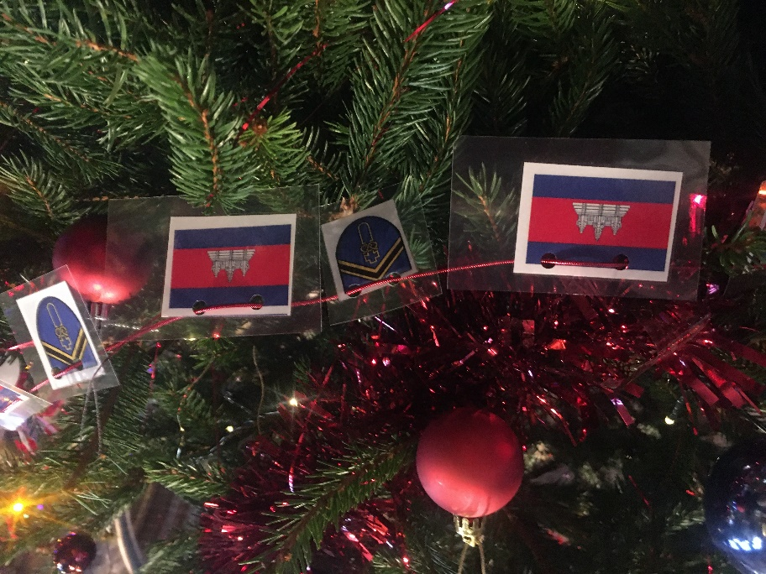
The annual St Mary’s Christmas Tree Festival was yet again an outstanding success, attracting thousands of visitors. Over 100 trees from local organisations and companies adorned the church from Wednesday 4th to Sunday 8th December 2019, including our very own Sir Graham Balfour Tree.

Our tree this year was decorated by our Cambodia 2020 team and celebrated our collaboration with our sister school in Cambodia. It is 5 years since the last tree was Cambodia themed and with the upcoming trip next February, it was a fantastic opportunity to raise awareness for both the school and the visit.

Thank you to the team for their hard work and fantastic display.

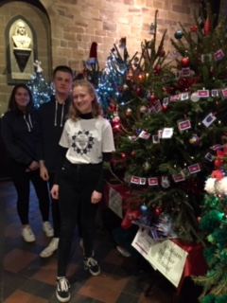
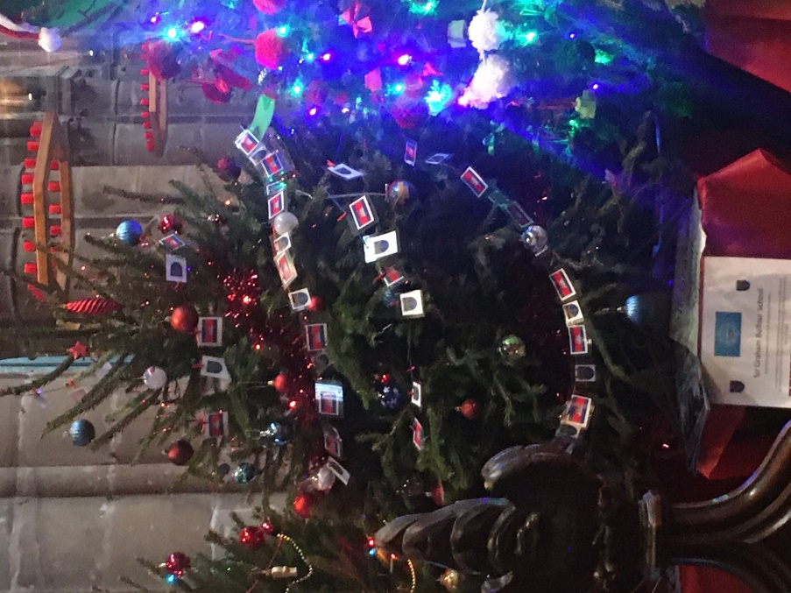

The Great Balfour ‘Cook Off’ Competition

On Wednesday 18th December we hosted The Great Balfour ‘Cook Off’ Competition. Six students took to the kitchen to produce a two course meal within an hour and a half timescale. Judging included how the students used their workspace and equipment, techniques used, menu choice plus ingredients used, and of course the taste of the dishes.
The competition was the internal preliminary stage of the Rotary Young Chef competition; the District heat takes place in February at Stafford College. All of the competitors were brilliant and the standard of the meals they produced would not look amiss in a restaurant setting. The judging panel consisted of Mrs Beck – Headteacher, Mrs Hill and Mrs Thompson from Perry’s of Eccleshall (Perrys Field to Fork Artisan Butchery and Cookery School). Selecting a winner was not an easy task. Eventually, the overall winner was announced as Sidney from Year 8, he will represent the school and the Rotary Club of Stafford Knot in the next stage of the competition.
Well done to everyone who took part; they were an absolute credit to both themselves and the ethos of the school. Pictured left to right: Kayla, Ashleigh, Mrs Beck, Jay, Ian, Sidney and Caitlin.
Mrs Gannon is planning to host further cookery competitions in the future, watch this space!
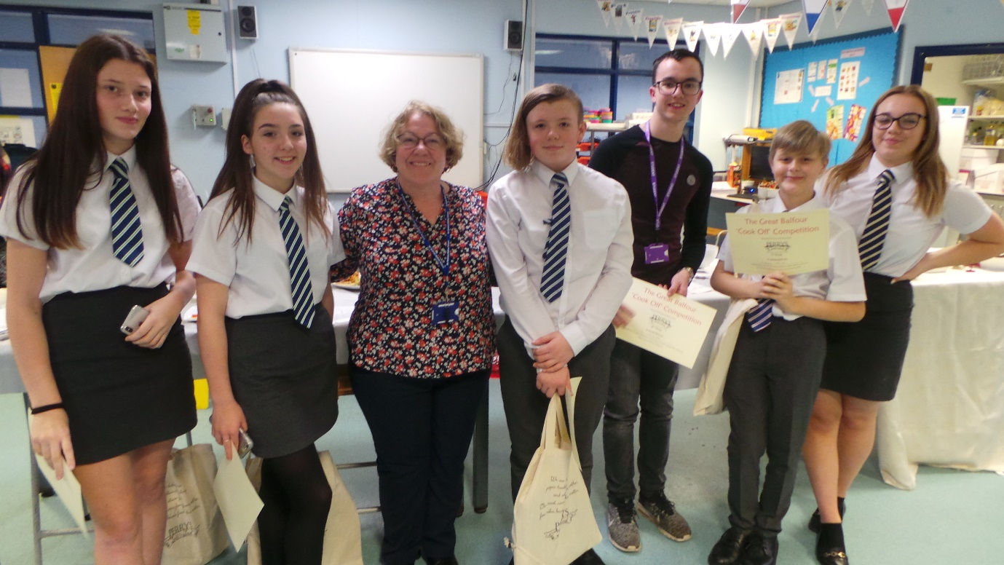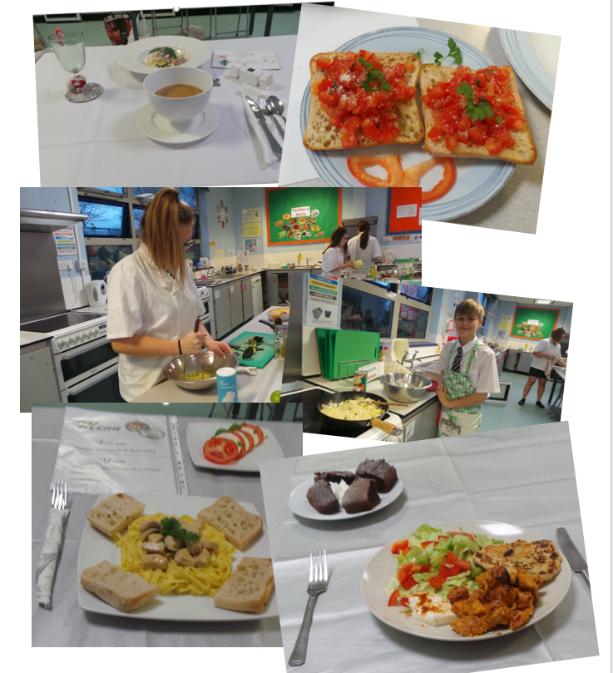
Fundraising
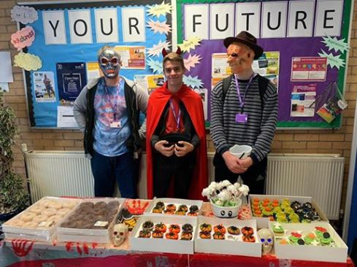
Halloween Bake Sale
24th October 2019

The Cambodia Team would like to thank all students and staff who bought from their Halloween Bake Sale.

A total of £130 was raised by the team, with proceeds going to their forthcoming trip in February 2020.

Children in Need

Our annual fundraiser for Children in Need and our school in Cambodia, took place on Friday 15th November. Students were asked to wear non-uniform for a donation and our Sixth Form organised various activities to support the event.
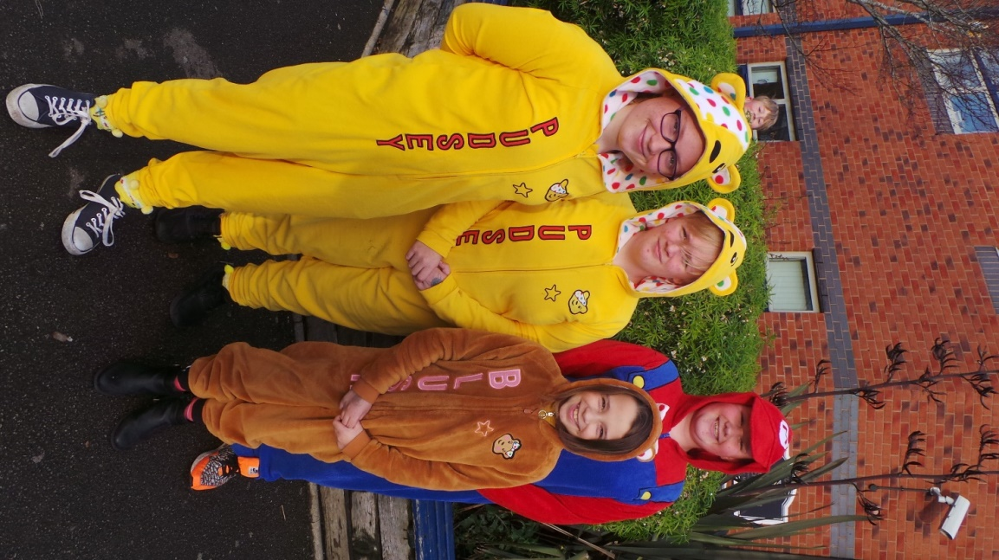
In total, we raised £914.54 which will be shared between this very worthy charity and our own.


Reverse Advent Calendar In Aid of House of Bread

For the third year running, Sir Graham Balfour has launched the Christmas Reverse Advent Calendar.

Rather than receive a treat, students have been asked to donate food and toiletry items on a daily basis in their House Groups, throughout December.

On the last day of term all of the items are amalgamated a series of hampers and collected by The House of Bread, the local provider of food and donations to the homeless and those in need in the Stafford area.

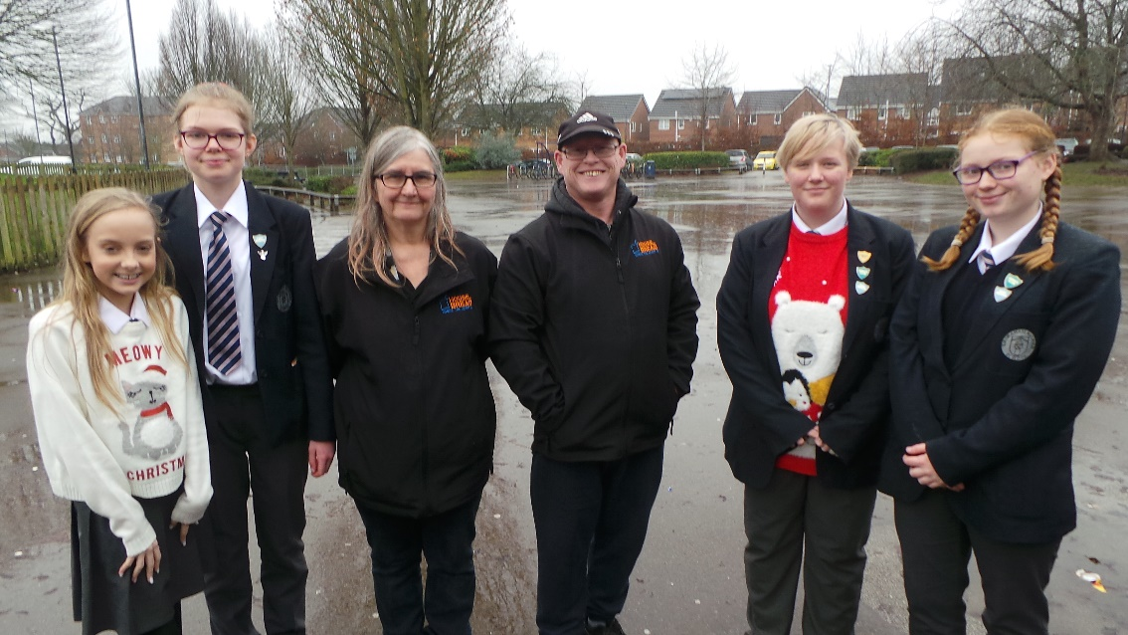
Thank you to all of the families of Sir Graham Balfour students for supporting this worthy charity and so generously donating items that will really make a difference at this time of year.

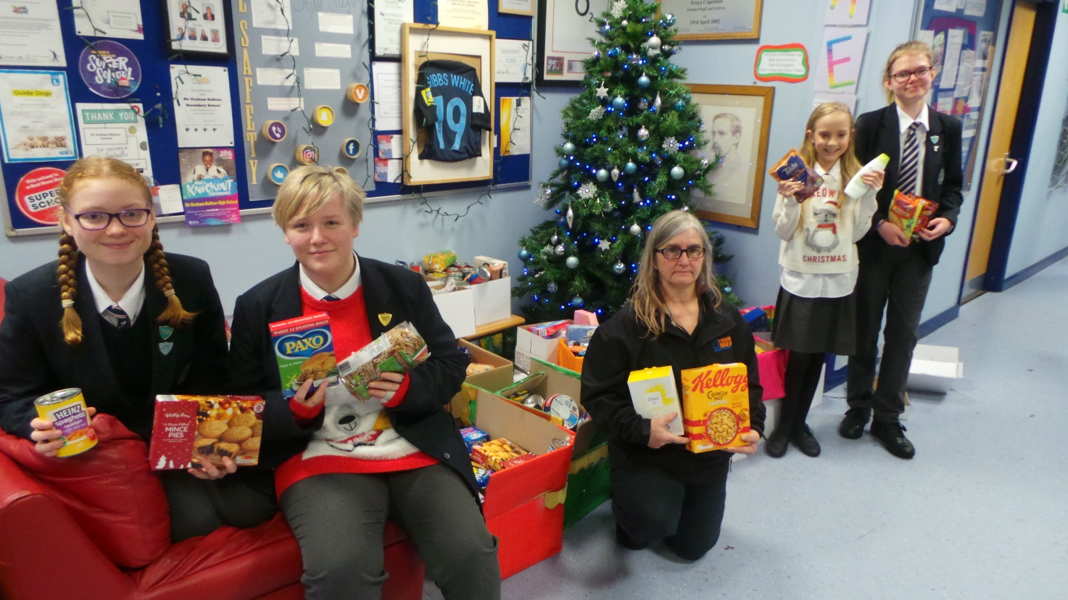

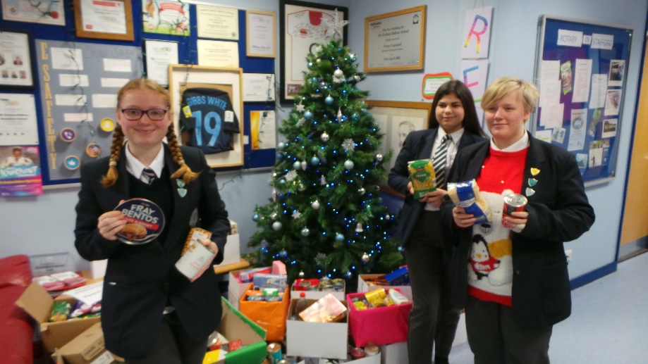

Katharine House Hospice – Christmas Tree Collection

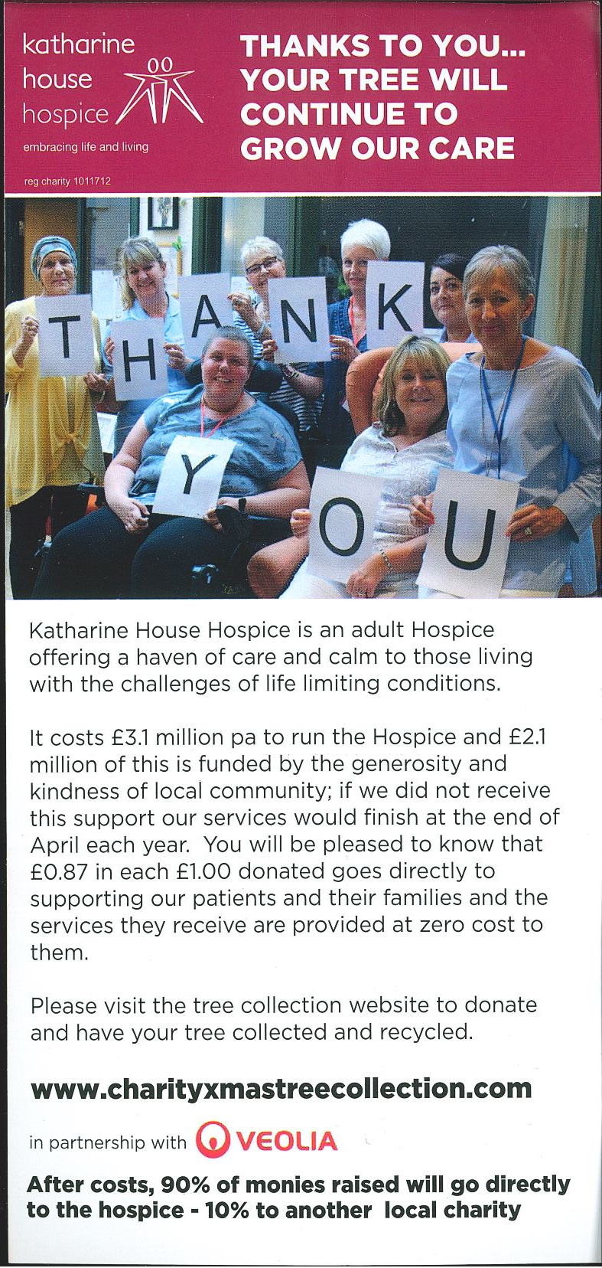

We have been asked by Katharine House Hospice to promote their Christmas Tree Collection Campaign. Please book your collection online at www.charityxmastreecollection.com

PSHE Day - Wednesday 20th November

Our first PHSE Day of this academic year took place on Wednesday 20th November and the theme was resilience.

Students experienced various visual and physical scenarios showing how people can overcome obstacles in life and become resilient in order to achieve and succeed. Some of the tasks included trying to break World Record attempts and producing a Snakes and Ladders board game themed on the aspects of Resilience. The day was extremely productive and positive.

Thank you everyone involved.

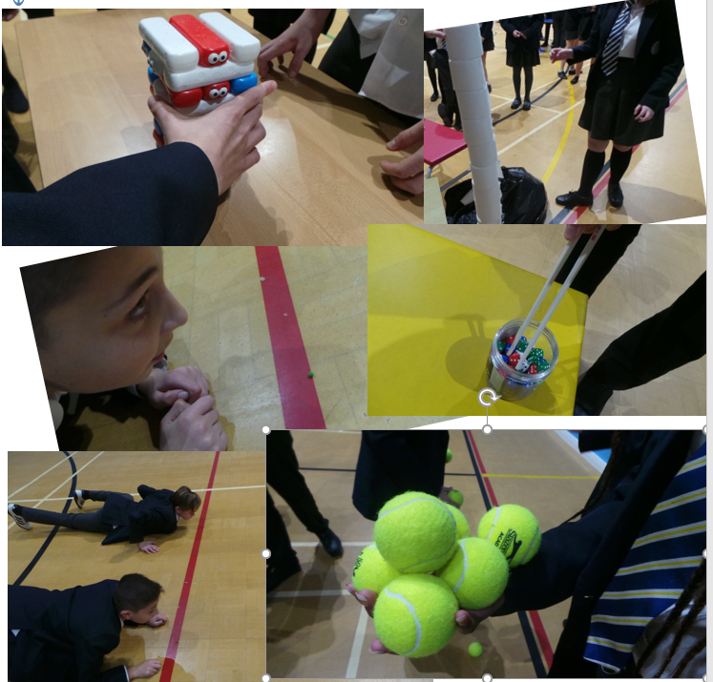

Accenture - Digital Technology Company Visit
Years 7 and 8 Computing – Hour of Code

On Wednesday 11th December, we were lucky enough to have staff from the digital technology company Accenture working with our Year 7s and 8s doing ‘Hour of Code’.

This is a world wide activity done by millions of students all over the world. They all go to https://www.tynker.com/hour-of-code/ to write computer code.

- Our Year 7s wrote the computer code to program an on screen dragon to solve puzzles, battle knights and find treasure.
- Our Year 8s programmed the instructions for a computer hacker to navigate mazes and destroy viruses.

This activity encourages students to practice their problem solving and computational thinking skills. Thank you to the representatives from Accenture and the support and help they give to our students.
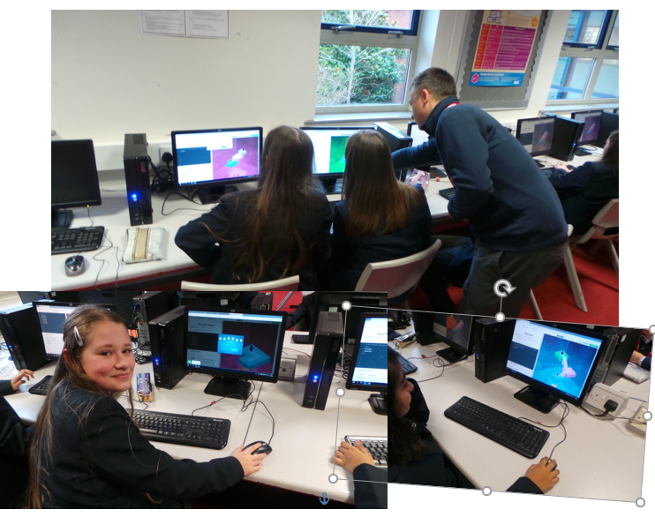

School Trips

The Woman in Black

Year 11 GCSE drama students attended a theatre trip to see The Woman in Black at the Regent Theatre, Stoke on Trent on Wednesday 9th November.

As part of their GCSE drama written examination, they have to watch and evaluate a piece of live theatre, showing their understanding of design elements alongside acting skills. The performance was brilliant, with both the students and Miss McKinley commenting on how cleverly presented it was with only 3 actors in the entire cast.

All students were impeccably well behaved (we expect nothing less) and represented Sir Graham Balfour School wonderfully. A big thank you to Mr Rowley and Mr Webb for accompanying!”

University of Derby Experience Day

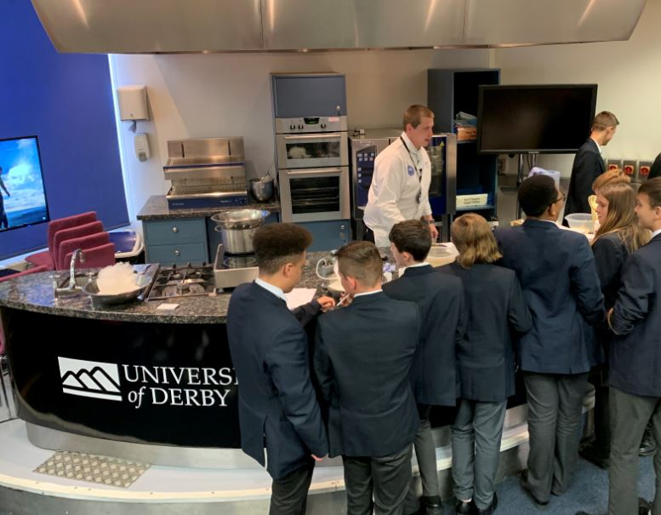

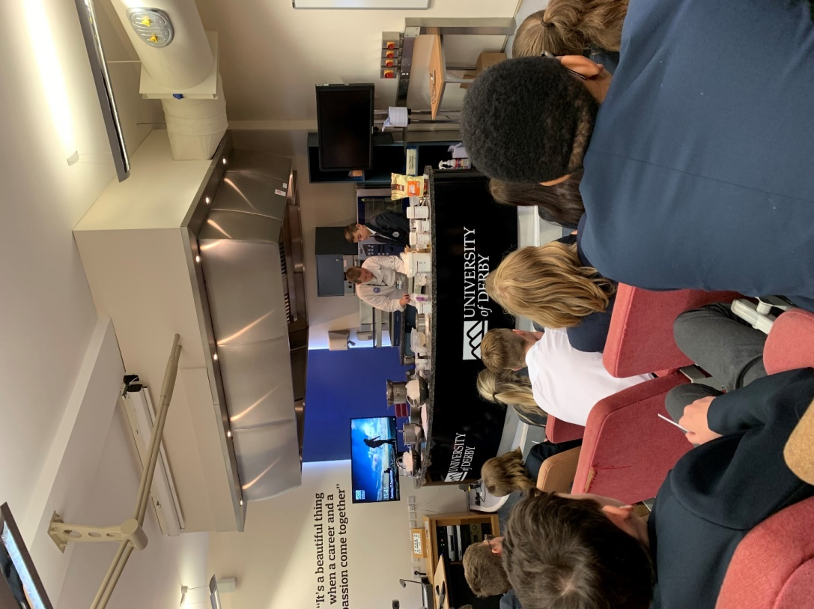
Thirty students from Year 10 were invited to attend a University Experience Day at the Buxton Campus of the University of Derby on 14th November 2020.

Students had the opportunity to attend Culinary Arts and Spa Management taster sessions and to learn more about progressing to university.

The day proved to be a very informative day and very much a learning curve for our students. 'It was a great experience'; 'Exciting, new and different' and 'It was a good insight into the University of Derby' were just a few of the quotes from students at the end of the day.

Following on from this day, 80% of the students that attended are now going to consider attending University in the future.

A great day was had by both students and staff alike!

Future Events

Y10 Work Experience Week

As we fast approach Christmas, our Year 10 students have been given the task of organising their work experience placement in readiness for our work experience week next July (6th – 10th). This year we have 165 students who will spend their week experiencing the world of work, with completed forms coming in thick and fast. As a school, we ensure that every provider is externally visited and assessed on their suitability for hosting one of our students. The support we receive as a school from local companies and organisations and a number of national companies is so appreciated and the benefits to our students are immense.

Year 11 End of Year Prom

Our Year 11 Prom has now been confirmed and will take place on Monday 29th June 2020 at The Moathouse, Acton Trussell.

Have a fabulous Chrismas break
and we look forward to
welcoming students back in school on
Monday 6th January 2020!



